**Development of Virtual lab :Round 1 (R1) Pedagogy - Template (Worksheet)**

|  |
| --- |
| **Name of Faculty:** Kamlesh gautam  **Institute:** **Rajkiya Engineering College Banda**  **Email ID** (as submitted in the registration form)**:**  **Discipline to which the Lab belong:**  **Name of the Lab:**  **Name of experiment**  (only one Experiment per worksheet. for submitting more than one experiments, please fill up another worksheet)**:**  **Kindly Refer these documents before filling the worksheet**   1. **Coursework (MOOC ) on Pedagogy , Storyboard , Lab Manual :**  [**http://bit.ly/Vlabs-MOOC**](http://bit.ly/Vlabs-MOOC) 2. **Additional Documentation booklet for reference.** [**http://vlabs.iitb.ac.in/vlabs-dev/document.php**](http://vlabs.iitb.ac.in/vlabs-dev/document.php) 3. **Sample Git Repository. :** |

**1.1 FOCUS AREA: Optics**

**1.2 About the Experiment**:lens can diverge and converge the ray of light. Whenever a ray of light fall on lens it’s formed real and virtual image. by the lens formula we can find the image distance.

Lens formula –(1/u)+(1/v)=(1/f)

u= object distance

v=image distance

f=focal length

according image distance and focal length of lens find distance and nature of image .

for the convex lens nature of image --

1. At infinity  
 2. Beyond 2F  
 3. At 2F  
 4. Between F and 2F  
 5. At the focus F  
  6. Between the focus F and optical centre C

For the concave lens nature of image –

1. At infinity  
    2. Between infinity and optical centre

**1.3 Learning Objectives:**

|  |  |  |  |
| --- | --- | --- | --- |
| **S.No.** | **Learning Objective** | **Cognitive Level** | **Action Verb** |
| 1 | Identify the relation between the object distance image distance and focal length of lens. | understand | describe |
| 2 | Describe the methodology to vary object distance and observe the image distance and nature of image | understand | examine |
| 3 | Predict the variation of image distance according to object distance. | apply | predict |
| 4 | Conclude about the image like that image distance nature of image and relation between u and v | evaluate | conclude |

**2. Instructional Strategy:**

**2.1 Instructional Strategy:**

**2.2 Assessment Method:**

**Quiz will be taken for evaluation (Example given below)**

**Pre test**

1.What is the ‘U’ in the lens formula ?

a)object distance b)image distance c)focal length d)radius of curavature

**post test**

1.What is the focal length of convex lens ?

a)positive b)negative c)zero d)none of these

2.What is the focal length of concave lens?

a)positive b)negative c)zero d)none of these

3.What is ‘F’ stand in lens formula ?

a)object distance b)image distance c)focal length d)radius of curavature

4.What is ‘u’ stand in the lens formula ?

a)object distance b)image distance c)focal length d)radius of curavature

5.What is the ‘V’ in the lens formula ?

a)focal length b)image distance c)object distance d)radius of curvature

6.What is the ‘R’ in the lens formula ?

a)focal length b)image distance c)object distance d)radius of curvature

7.What is nature of convex lens ?

a)converging b)diverging c)don’t know d)none of these

8.What is nature of concave lens ?

a)converging b)diverging c)don’t know d)none of these

9. In which condition the convex lens formed image at infinite ?

a) U=R b)U=V c)U=F d)U=0

10. What is the condition virtual image in convex lens ?

a)U>R b)F<U<R c)U<F d)none of these

**2.3 Description of sections:** in order to find the the image distance for varrying object distance and show the nature of image using concave and convex lens.

First of all we know two factor:

1.image distance

2.focal length of lens

Using the lens famula find the image distance

(1/u)+(1/v)=(1/f)

u=object distance

v=image distance

f=focal length

**one example of image formation:**

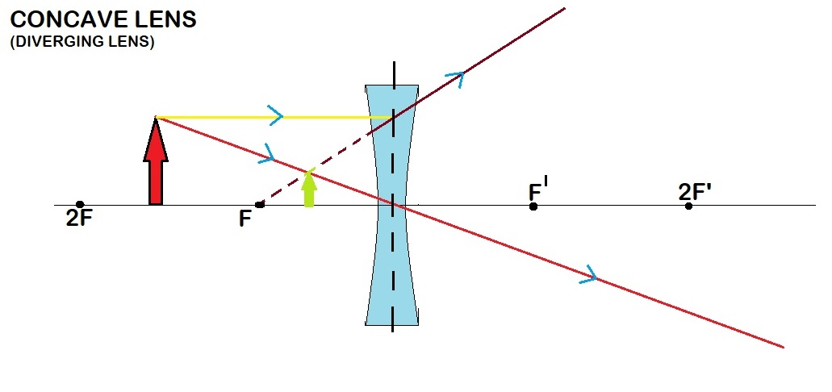

**Result**:1.give the image distance

2. nature of image formation

3.graph of ‘u’ and ‘v’

**CALCULATION:**

Calculate the image distance by object distance in the graph

**3. Task & Assessment Questions**

|  |  |  |  |
| --- | --- | --- | --- |
| **SrNo.** | **Learning Objective to be met** | **Tasks to be performed by the students** | **Assessment questions aligned to the task** |
| **1** | Recall the concept of image formation by lens | student take one by one different value and analyse nature of image | 1. In which condition the convex lens formed image at infinite ?  a) U=R b)U=V c)U=F d)U=0 |
| **2** | Student can Predict the variation of image distance according to object distance | Student select the value of u and f .accordingly this image distance change | 1.What is nature of convex lens ?  a)converging b)diverging c)don’t know d)none of these |
| **3** | Describe the methodology to vary object distance and observe the image distance in lens | Student select the graph button and read the graph clearly. |  |
| **4** | Conclude about the image like that image distance nature of image and relation between u and v | Student perform the experiment on simulator . | What is the condition virtual image in convex lens ?  a)U>R b)F<U<R c)U<F d)none of these |

**4. Simulator Interactions**

|  |  |  |
| --- | --- | --- |
| **What students will do?** | **What simulator will do?** | **Purpose of the task** |
| Student will select the button for lens . | Simulator select type of lens that use for experiment . | Purpose that take input of image distance and focal length of lens and also initiate the simulator. |
| Student input the value of ‘u’ and ‘f’ and select the ‘v’ button | Simulator find the image distance and behavior of image with respect to object. | to check the behavior of image . |
| Student will press the u and v graph button | Simulator show the u and v graph. But it’ a constant graph | Show by graph image distance with respect to object distance. |